English Language Arts 11

Course Outline

2017 - 2018

Ms. Otke
This year we will be studying a variety of different literary forms and themes. We will read short stories, poetry, novels, and much more! You will have opportunities to read and research topics that interest you and share what you have learned with your classmates in a variety of formats.

Curriculum:

The English Language Arts curriculum have been redesigned to meet the needs of the 21st Century Learner. More information can be found on the Ministry of Education Website.
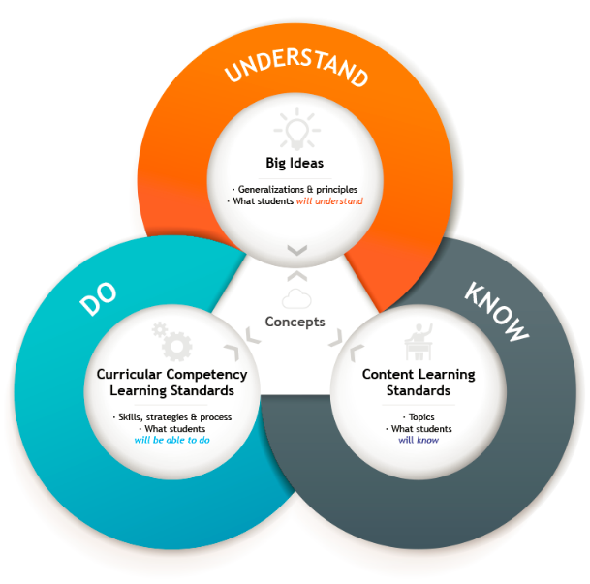
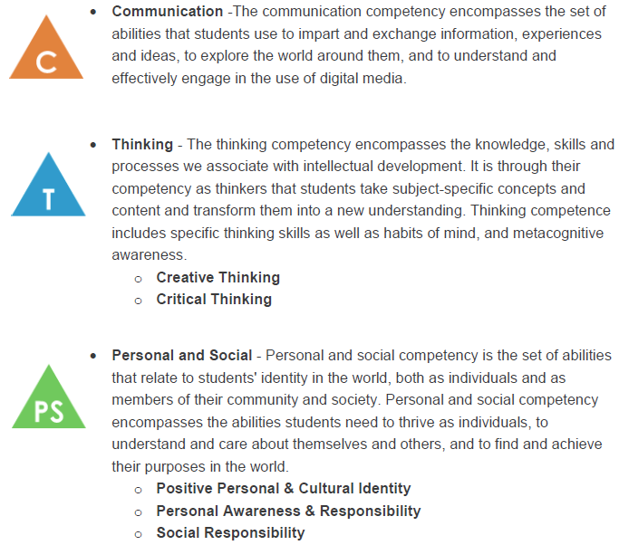

Areas of Exploration:

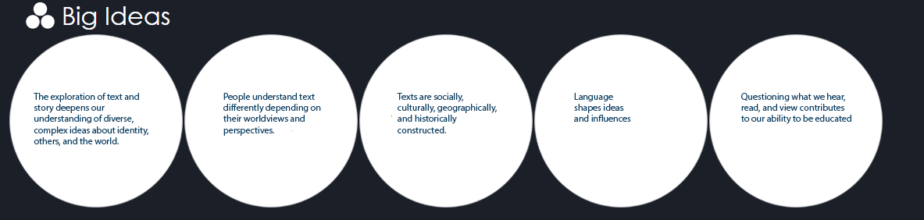

- Short Stories & Essays
- Expository & Narrative Writing
- Novel & Literature Study
- Grammar
- Speaking & Presenting
- Other literary forms including Poetry, Drama and Graphic Storytelling

Assessment:

- Assessment encompasses a variety of formative and summative activities, and includes self, as well as teacher assessment.
- Up-to-date assessment information for each student will be available through Fresh Grade. Please see my website, or watch for the parent email in mid-September.
- Typically, assessment is weighed more heavily towards classroom assignments, not tests. As a result, it is my classroom policy that tests cannot be rewritten.
- See my website and “Expectations and Information” (below) for more information

Contact Information:

By E-mail: amber.otke-ropotar@sd23.bc.ca
In my classroom: E-3 (East Wing)
By Telephone: (250) 870-5108 (Okanagan Mission Secondary)

My Website: www.aotkeropotar.weebly.com
Twitter: @msotke
Materials Required:
- 3-Ring Binder
- Two different colored pens (pencil is not acceptable for final drafts)
- Lined paper (there is quite a bit of writing in this class)
- USB Storage device (Google Drive is also available)
Silent Reading:

- Reading is an important part of the English Language Arts curriculum. Students should bring reading material to every class. Acceptable material includes books (fiction or non-fiction), magazines with significant written content (Rolling Stone, news magazines, etc.), and graphic novels. Physical books are preferred to e-materials.

A Note about Cell Phones:

- Cell phones can be an important educational tool. However, cell phones can also be a colossal distraction. Students should leave their cell phones and other devices in their lockers. If a student has their phone with them (for any reason), it should be set to silent. Students who are distracted by their phone during class time will have it removed. It will be available for collection at the end of the day.

- Students will be advised ahead of time if we are completing an activity where cell phones are permitted.

Attendance & Homework:

- Regular attendance is important for success in the classroom. Absence will impact student’s achievement. Students can check the teacher website for information on missed assignments.
- Students will generally have enough time to complete assignments during class time, however, students who do not use time efficiently will have work to complete at home.

Expectations and Information:

- All assignments are expected to be the student’s own written work and ideas. Information downloaded from the Internet, or other sources, without the appropriate citation will be considered plagiarism, and be awarded a zero. This includes copying work from friends or siblings, and your own work from another class or a previous year!

- As this is a writing and composition-based course, frequent written assignments, notes and activities should be expected. Bring lots of paper!!!

- Editing is an important part of the writing process. Occasionally, assignments will be returned to the student for a rewrite. This is also part of the writing process. Please clarify errors with the teacher, rewrite, and then hand in. Rewrites are generally assigned a “0” or "R" grade, until they are completed in a satisfactory manner.

- Late projects and assignments are not tolerated. Please hand assignments in on time. Late assignments affect your work ethic mark.

- Keeping in mind that this is Humanities class, the use of proper (and appropriate) language (grammar & usage) is expected. Assignments using "txt"-speak will be returned for rewrites.

- Please keep in mind that what is written on the board, or presented during a PowerPoint is important information. While you do not have to copy word for word, actually writing it down is important. You may not take pictures.

- Any written work that is to be handed in should either be neatly printed or handwritten in pen (not pink, red, orange or yellow), or be typed (12 pt. font, Calibri or Times New Roman). All assignments should be double-spaced, unless otherwise indicated. Final drafts written in pencil will not be accepted.

- Due to severe allergy concerns, food is not allowed in the classroom. Water is permitted, and must have a spill-proof top.

- Please do not bring your toys to class. Fidget spinners and similar devices are considered toys. (Reasonable accommodations are available, and must be discussed with the teacher)

- DO NOT WEAR HEADPHONES IN CLASS – EVER.

